SPLIT TYPE WALL MOUNTED AIR CONDITIONER
User Manual of Smart Air Conditioner App

1. Instruction
Smart air conditioner is an air conditioner with Wi‐Fi remote control system. It could
be controlled by your smartphone with 2.4G Wi‐Fi, 2G, 3G ,4G network.

2. App download link

Scan the QR code to download Smart App
Note: After the initial installation of iOS version, may be prompted to remind, as
shown below. Go to Phone Settings ‐ General – Profiles & Device Management, tap
on“Hangzhou Miaoyong Technology…”‐“Verify Apps”, and select “Verify”. Then open
App again
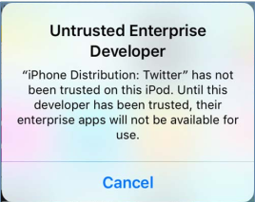
3. Operation instruction
3.1. Register account：
When you open the App for the first time, start your registration. Tap on "Register" at
upper right corner of the login page, Type in your Email address or mobile number,
tap on “Next” and receive a verification code. Type in the code and confirm your
password, and then tap on “Confirm”. After successful verification, registration
process is finished and App goes to the home page.

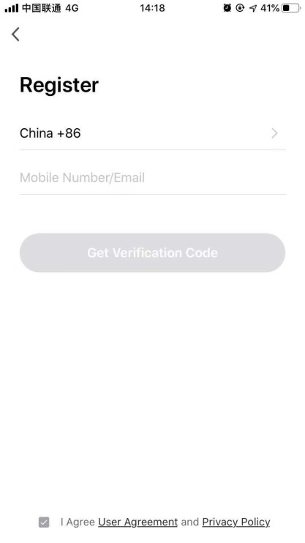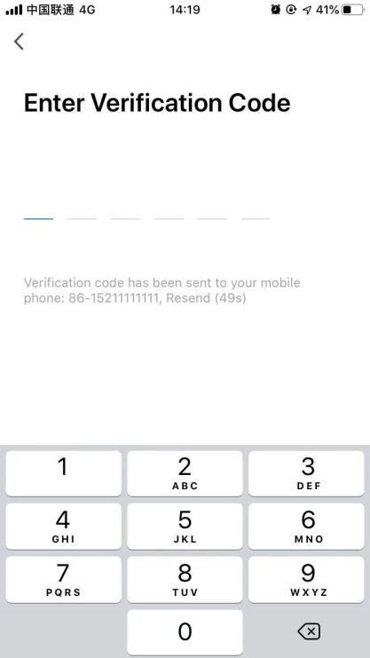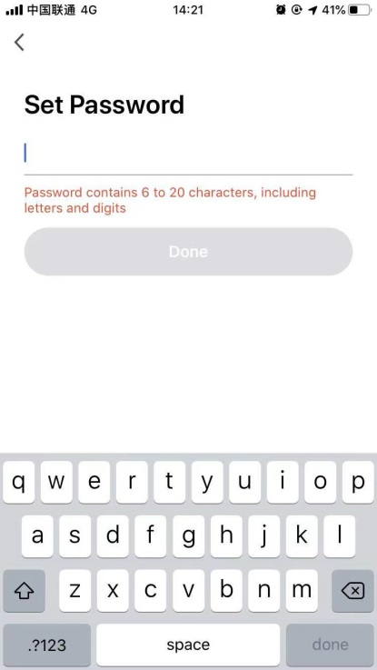

3.2. How to add device?
3.2.1Please make sure that the device is on the pending status awaiting to be
connected. If not, please reset the device via the following procedures: Long press
the reset‐button for 5s－ buzzer sounds－ the WIFI icon on device is quickly
flashing (approx. 3 times/s). Then it indicates that the device is successfully reset and
has entered into Smart mode.
3.2.2Open the App, tap on 【Add device】 , select your own Wi‐Fi network, type in
your own Wi‐Fi router password and tap on “ Next” . Then the network configuration
starts.
3.2.3When configuration is successful, you could see the app interface as shown in
the screenshot below.
3.2.4Tap on【Done】 , you could see the interface of a device list as shown in the
screenshot below.
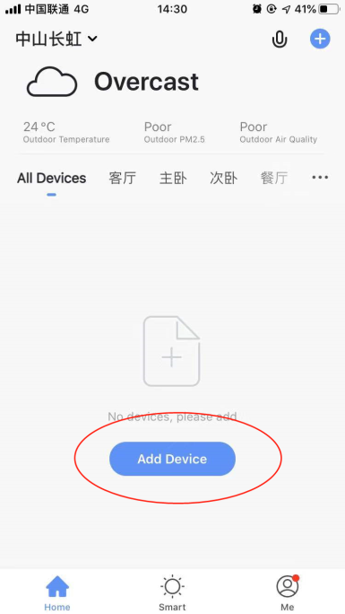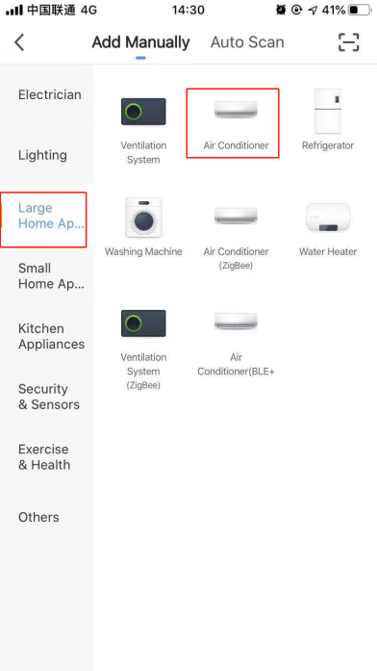
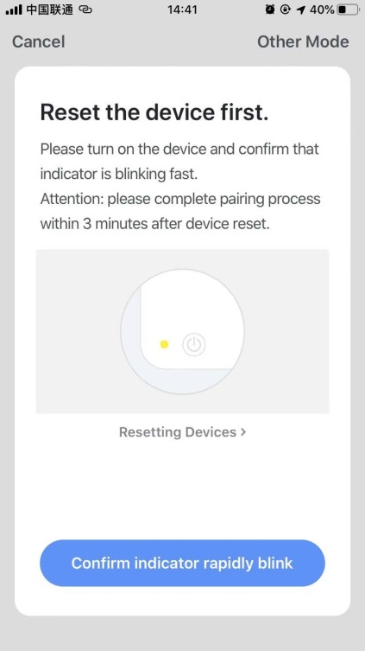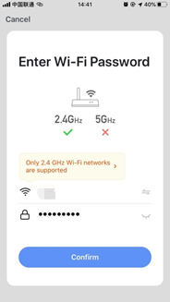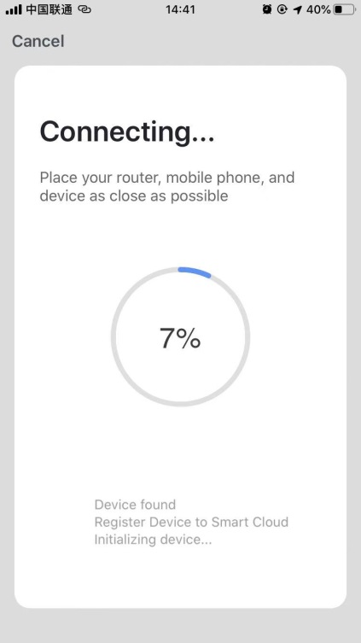
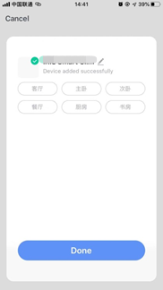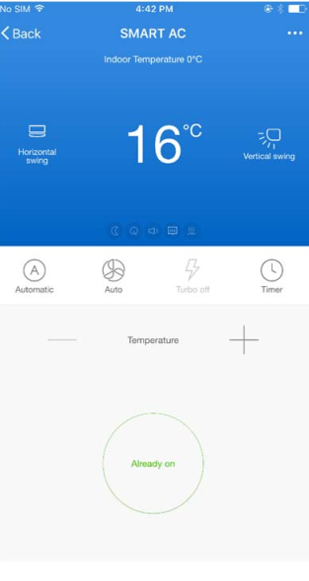
3.3. What if connection failed?
When the connection failed, you could see the the App interface as shown in the
screenshot below. Please try to configure network again or switch to AP mode.
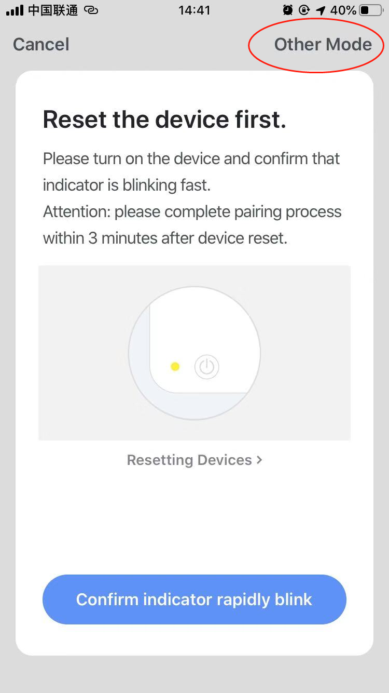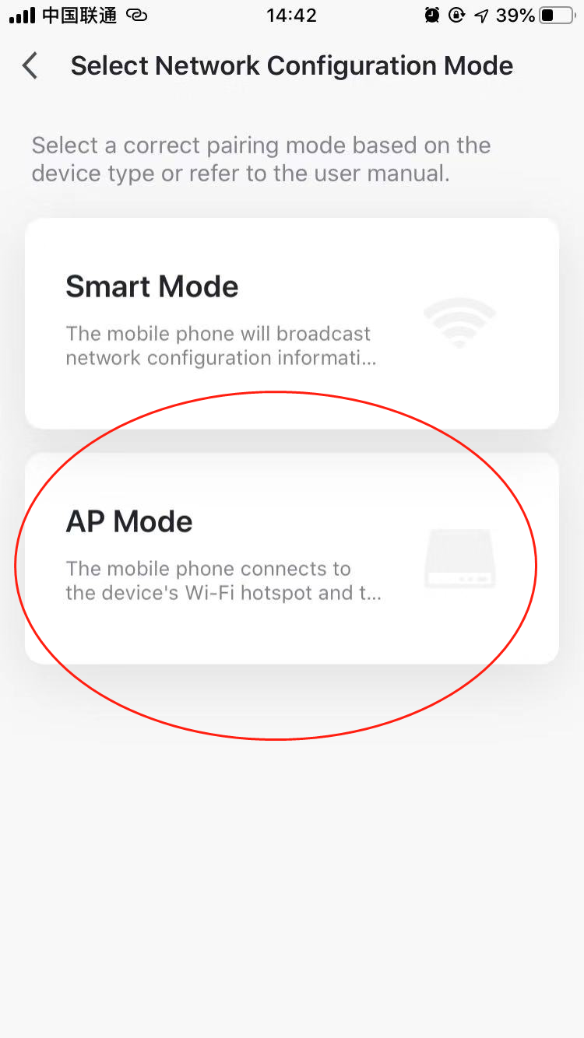

3.3.1. Continue to connect by switching other connection mode.
1.Tap on【AP mode】 , configure network via AP mode with the following procedures.
2. Switch Air conditioner to AP mode: When it is under smart mode, long press
reset‐button for 5 seconds‐buzzer sounds－ the heating icon on device is slowly
flashing (approx. 1.5 times/s). It indicates the Air conditioner has entered into AP
mode
3. Connect to device hotspot: Tap on 【Connect】 (open phone settings‐WLAN),
connect to the hotspot named “SmartLife‐XXXX” (The name of WIFI may vary, depending on the actual product), then the network configuration starts as shown in the screenshot.
4. After successful network configuration, tap on “Done” and the device list interface
appears.
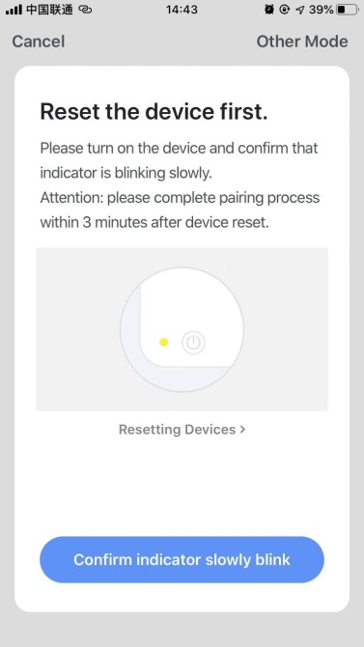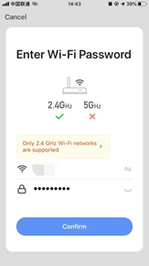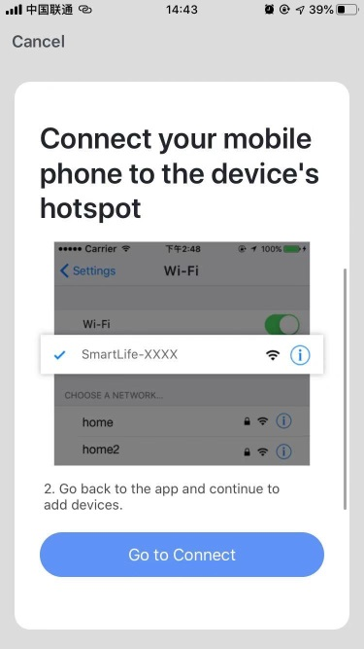
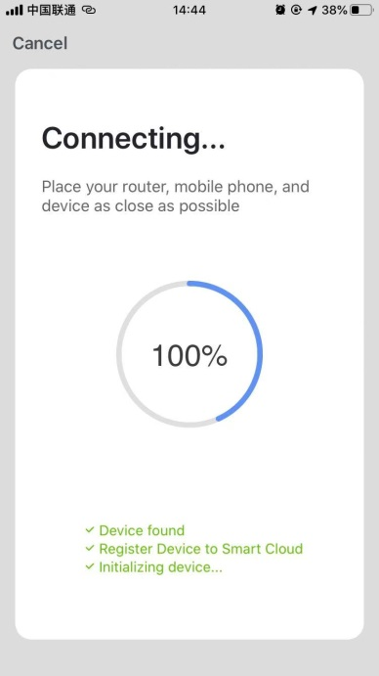
3.3.2. Add device again from device list
1. Open App, tap on【AP mode】 at upper right corner, connect to device via AP
mode with the following procedures.
2. Select your own Wi‐Fi network, type in your Wi‐Fi router password, and tap on
“Next”
3. Switch Air conditioner to AP mode: When it is under smart mode, long press
reset‐button for 5 seconds‐buzzer sounds－ device’s indicator light is slowly
flashing (approx. 1.5 times/s). It indicates the Air conditioner has entered into AP
mode
4. Connect to device’s hotspot: Tap 【 Connect】 (open phone settings‐WLAN),
connect to the hotspot named “SmartLife‐XXXX” (The name of WIFI may vary, depending on the actual product), then the network configuration starts as shown in thescreenshot.
5. After successful network configuration, tap on “Done” and the device list
interface appears.
3.4. Device control
3.4.1 Select the device and enter the main control interface as shown in the
screenshot below.
3.4.2 Tap on【Switch】 to turn on/off Air conditioner
3.4.3 Tap on【Mode】 to switch the working mode
3.4.4Tap on 【Speed】 to control the wind speed
3.4.5 Tap on 【Left‐right swing】 to turn on/off left‐right swing function
3.4.6 Tap on【Up‐down swing】 to choose the wind direction such as swing, direction
1, direction 2, direction 3, direction 4, direction 5 and etc.
3.4.7 Tap on 【Multiple functions】 to select more functions such as sleep, air
freshening, electrical heating. “Display” function is to turn on/off the display screen
of air conditioner.
3.4.8 Tap on 【Timer】 to automatically turn Air conditioner on/off at a specific time.
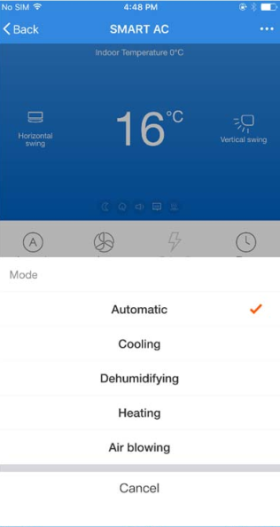
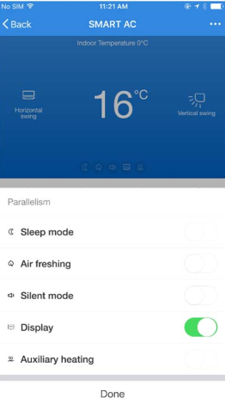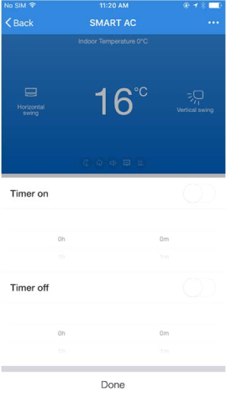
3.5. Modify device name
Tap on upper right corner of the main control interface, select 【Modify】 , type in the new device name on the pop‐up dialog, and tap on 【Save】.
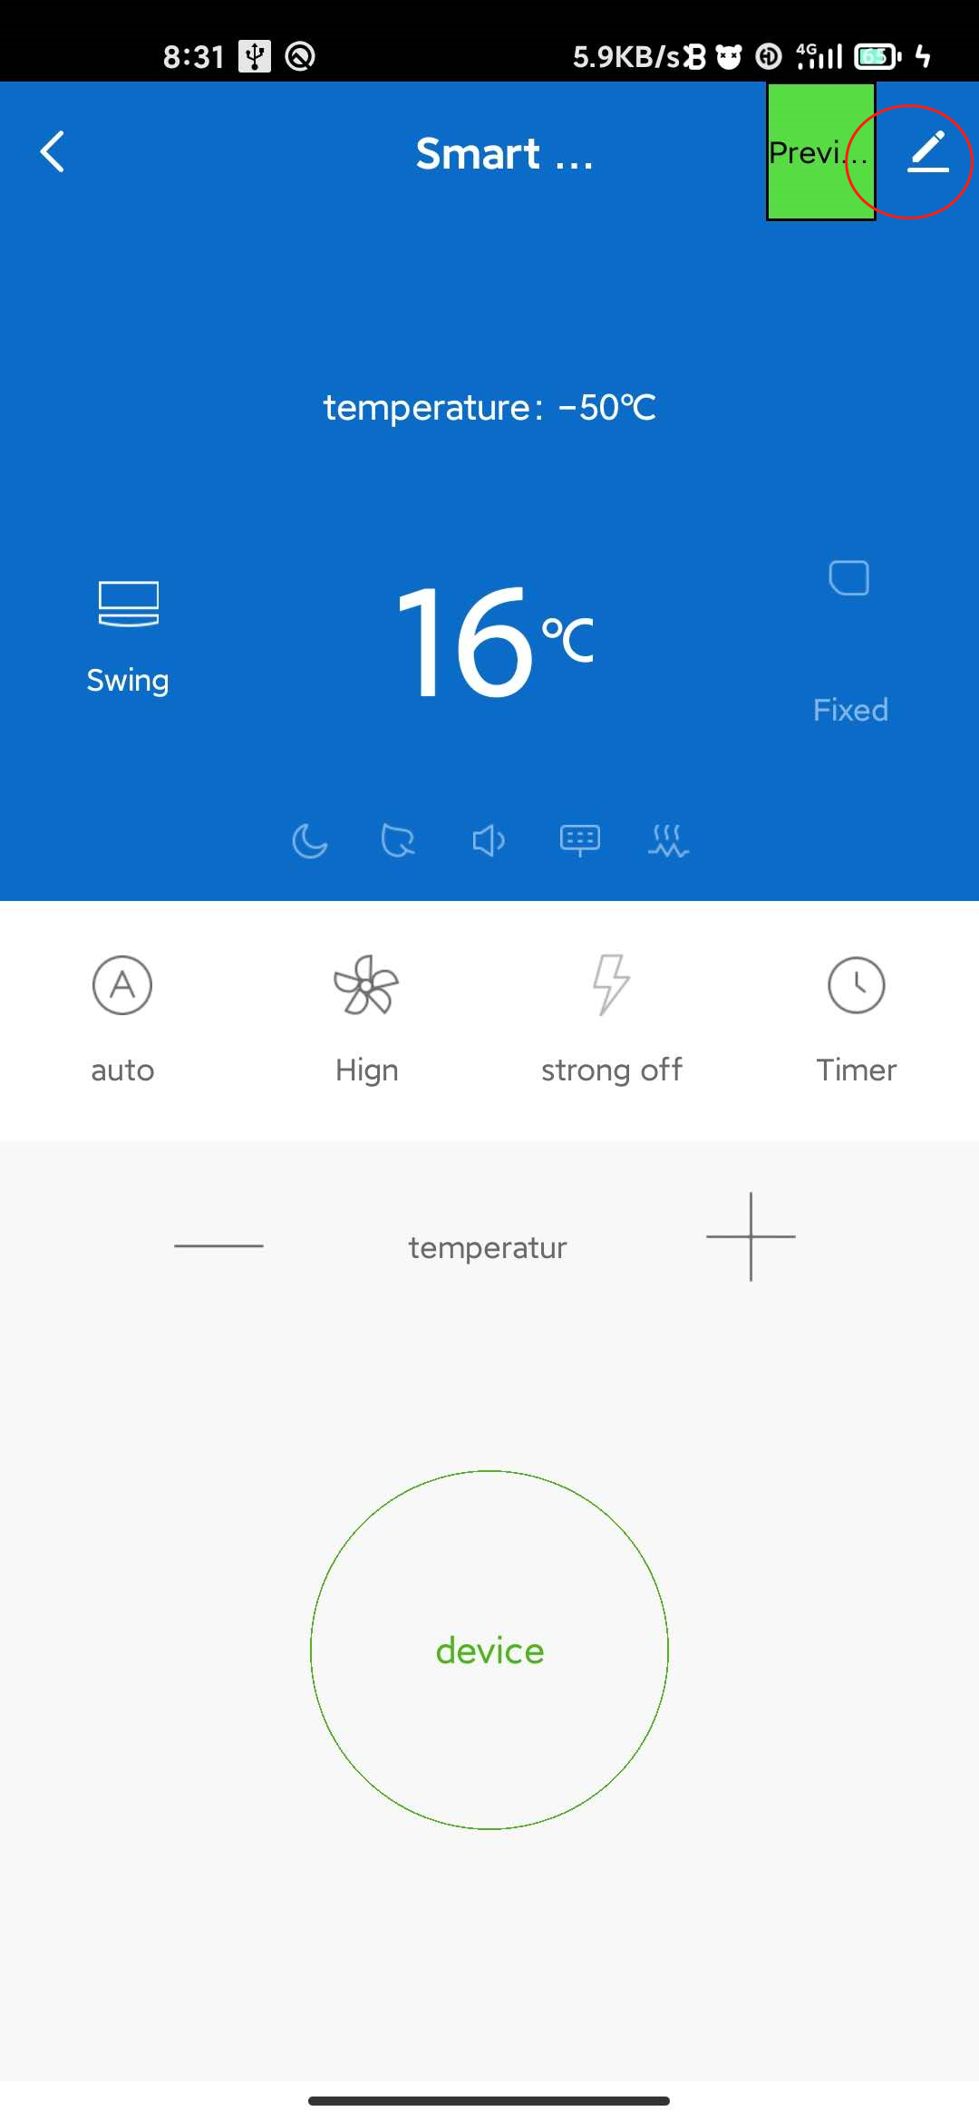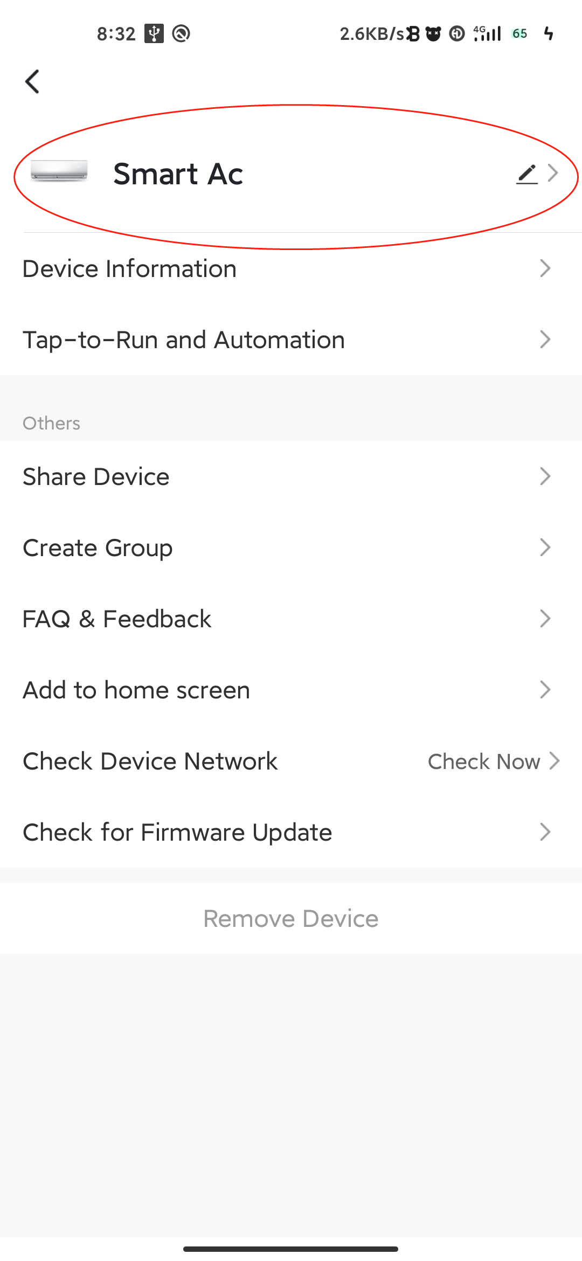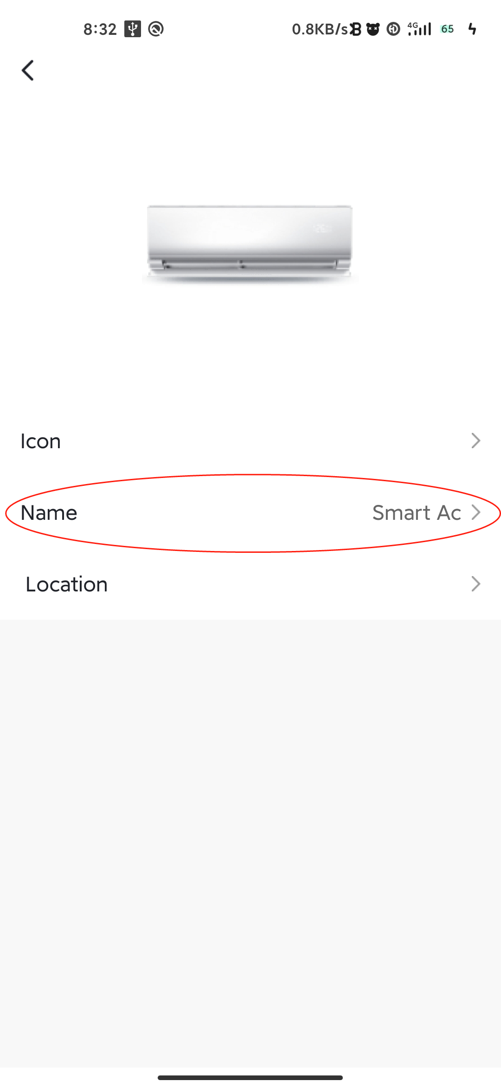
3.6. Delete device or Reconnection
3.6.1Tap on upper right corner of the main control interface, select【Remove device】 , the dialog pops up to notify you whether to remove device. Tap on【Confirm】 , device will be removed from the App and switched to reset status.
3.6.2 Long press the reset‐button for 5s－ buzzer sounds－ the WIFI icon on device is quickly flashing, It will force an existing connection to be disconnected and needs to be re paired.
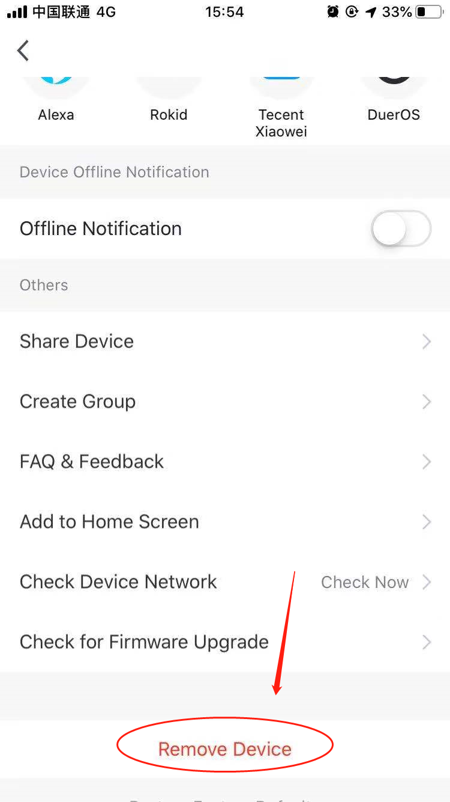
3.7. Share device
Tap on【Home Management】 , select 【Home name】 ‐【Add Member】,input the account you want to share.
in other’s account number, tap on【Confirm】 . The person would receive the sharing
settings and easily control the device with smartphone App.
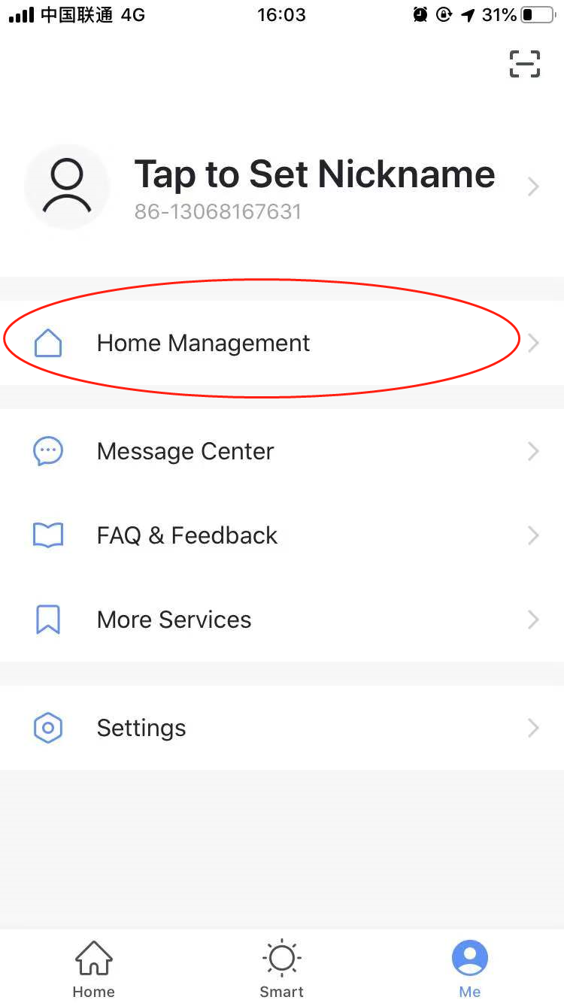
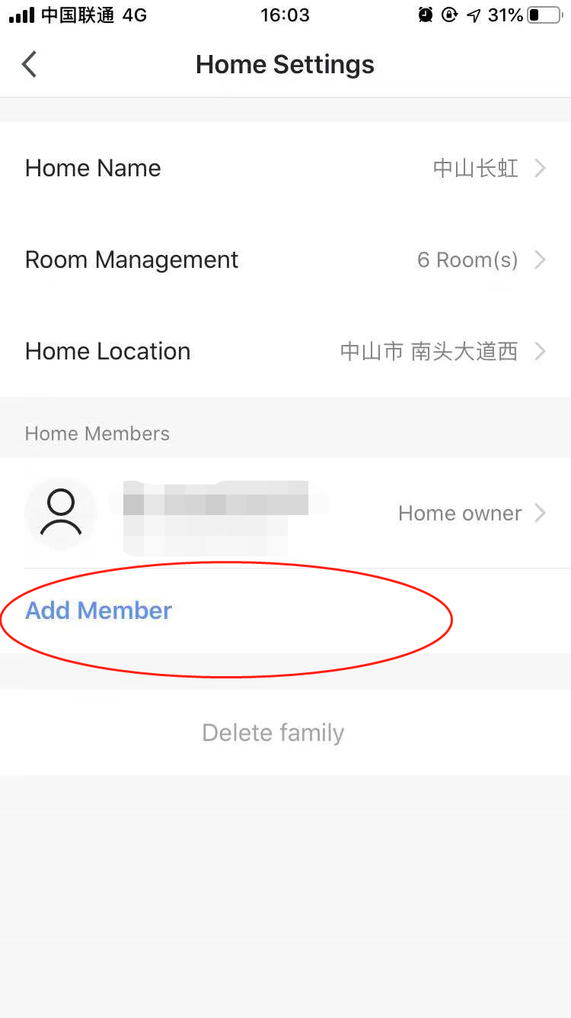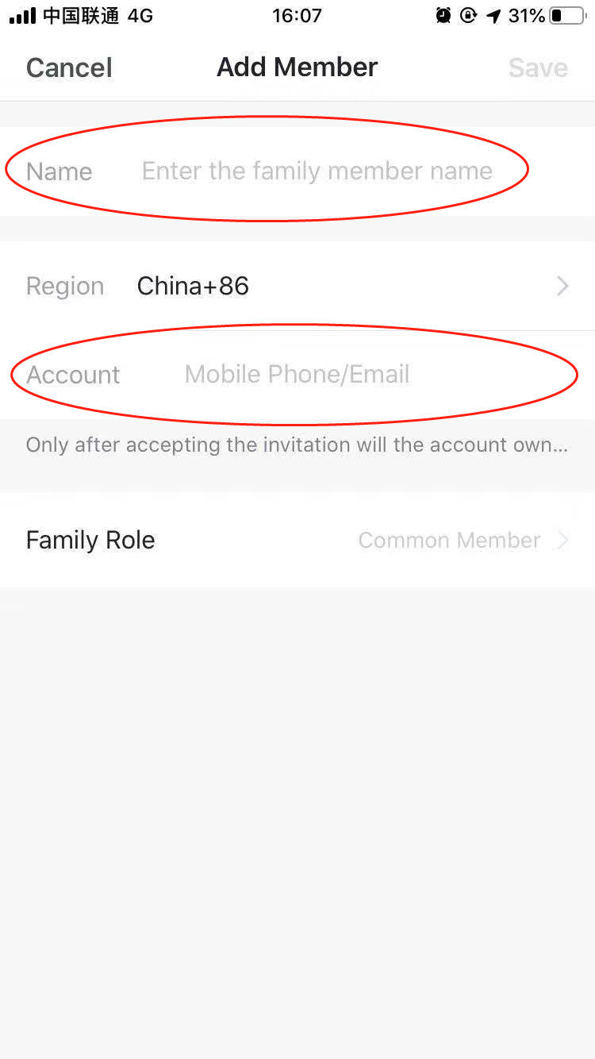
Remarks: If you sign in with a third‐party account (Email address, Facebook and
Twitter), you need to bind to your mobile number in order to share device with
others.
3.8. Vibration and sound
On 【Profile】 page, tap on 【Settings】 button at upper right corner. You could then
turn/off vibration or sound, as shown in the screenshot below.
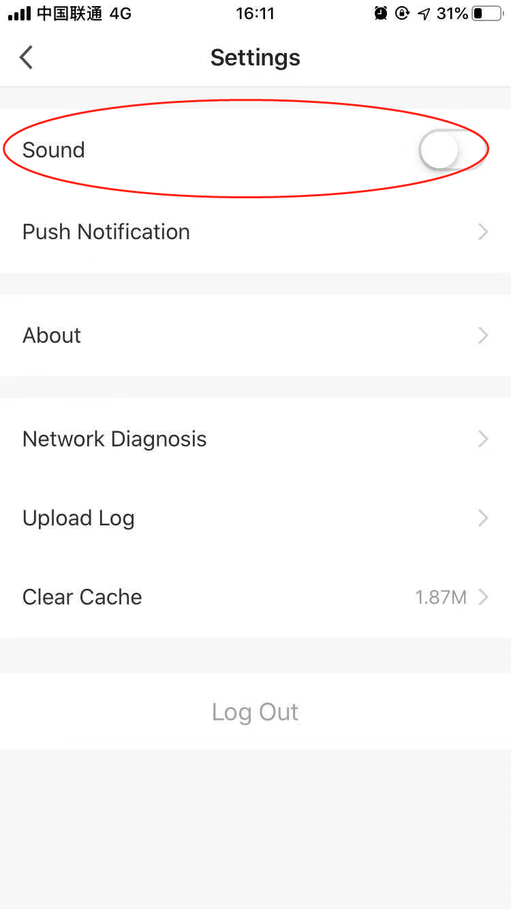
4. Profile
4.1. Logout
On 【Profile】 page, tap on the personal profile menu, you could then logout the
current account.
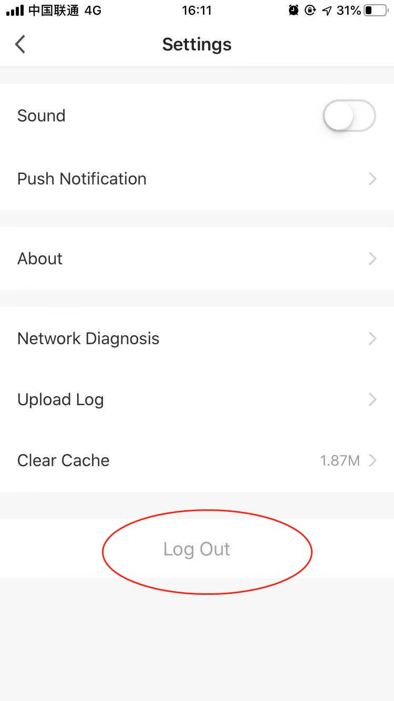
4.2. Modify profile information
On【profile】 page, tap on the personal profile menu to modify the profile picture,
name and other account information.
4.3. FAQ&Feedback
On【profile】 page, tap on【Faq&qFeedback】 menu to submit your feedback.

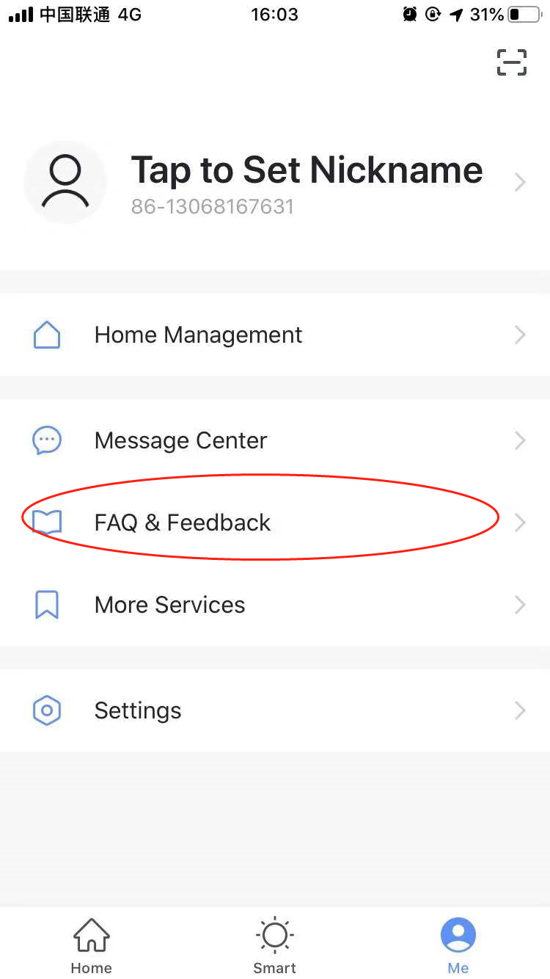

5.WIFI Attentions
5.1 Important notifications
To prevent unnecessary harm, please keep in mind of the following notifications
Please don’t use Wi‐Fi where the wireless device is not allowed, such as airport,
medical places and etc.
Please don’t turn on your smartphone in dangerous places, such as gas station, fuel
or chemicals manufactures, and etc.
Please don’t use mismatched devices.
Please find a qualified repair man to fix the Wi‐Fi.
Please refer to the user manual for the detailed connection methods, please don’t
randomly use mismatched devices.
5.2 Notifications：
5.2.1 The App control quality is affected by your smartphone, Wi‐Fi network,
distance with router, and internet status. Sometime it is not very smooth. It has
nothing to do with air conditioner itself；
5.2.2 If you find it failed to control with your smartphone, please check your internet
status at first, then check whether it is successfully connected with air conditioner; If
these circumstances are alright, please delete the device first on your App and start
the procedures all over again from the step 3.2.
5.2.3 If you still cannot solve the issues with the methods above, please control the
Air conditioner with your normal remoter and then request for after‐sale service.

